CREATION OF DATABASE USING DDL ,DML STATEMENTS

TABLE 1:

CREATE TABLE PERSON

(

NAME CHAR(18) NOT NULL,

AADHAR_NO NUMBER(20),NOT NULL

MOBILE_NO NUMBER(10) NOT NULL,

EMAIL VARCHAR(20),

ADDRESS VARCHAR(50),

PINCODE NUMBER(6);

BLOODGROUP VARCHAR(5) NOT NULL,

CITY CHAR(12),

TYPE CHAR(10),

CONSTRAINT PERSON_PK PRIMARY KEY(AADHAR_NO),

CONSTRAINT PERSON_MOBILE UNIQUE(MOBILE_NO)

);

OUTPUT:

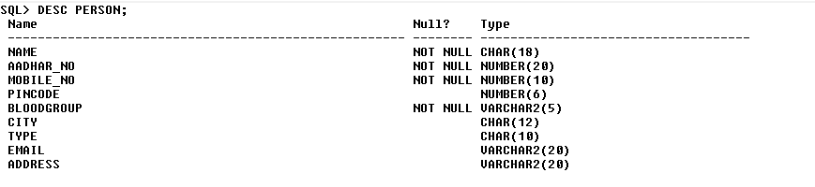

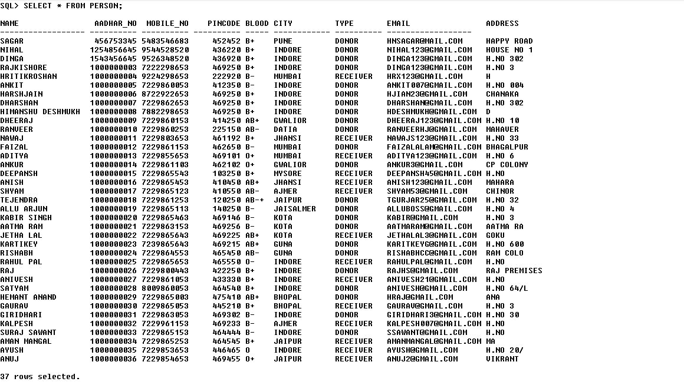

CREATE TABLE HOSPITAL

(

REG_NO VARCHAR2(6),

H_NAME VARCHAR(30) NOT NULL,

H_ADDRESS VARCHAR(20) ,

H_EMAIL VARCHAR(20) ,

H_PINCODE NUMBER(6) NOT NULL,

H_CITY CHAR(20) NOT NULL,

BLOOD_GROUP VARCHAR(5) NOT NULL,

AVAILABILITY NUMBER(5) NOT NULL,

CONTACT_NO NUMBER(15) NOT NULL,

CONSTRAINT HOSPITAL_AVAI CHECK(AVAILABILITY>=0),

CONSTRAINT HOSPITAL_PK PRIMARY KEY(REG_NO);

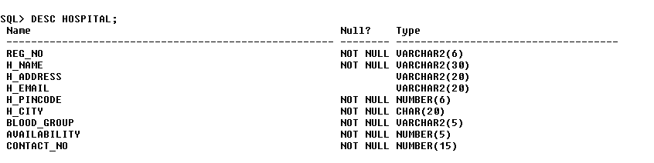

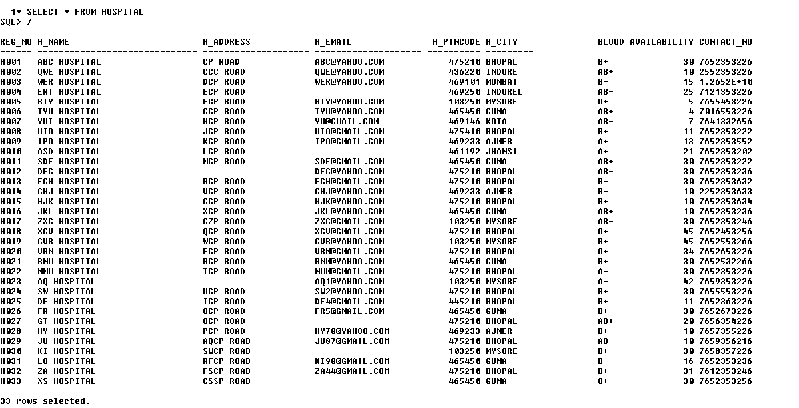

CREATE TABLE BLOODBANK

(

NAME CHAR(24) NOT NULL,

ADDRESS VARCHAR(50) NOT NULL,

PINCODE NUMBER(8),

BLOODGROUP VARCHAR(5),

AVAILABLE NUMBER(10),

AADHAR_NO NUMBER(20) NOT NULL,

REG_NO VARCHAR(6),

CONSTRAINT BB1 FOREIGN KEY(AADHAR_NO)

REFERENCES PERSON(AADHAR_NO),

CONSTRAINT BB2 FOREIGN KEY(REG_NO)

REFERENCES HOSPITAL(REG_NO)

);

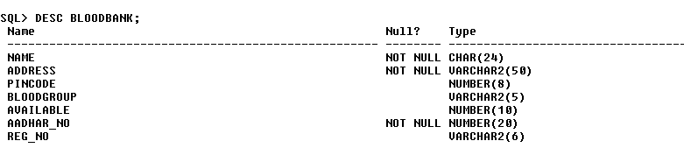

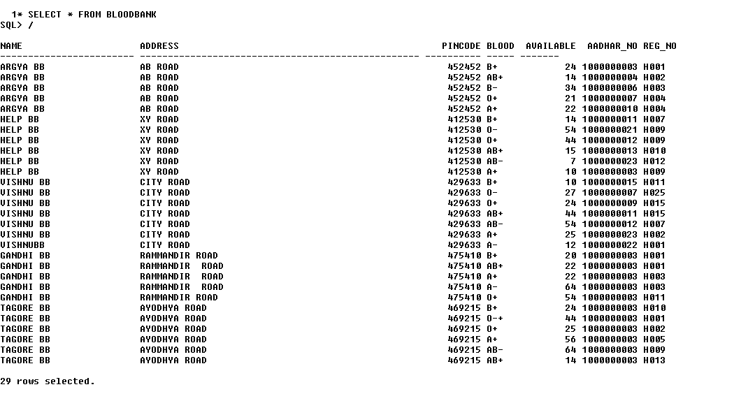

**SOME MORE OUTPUT IN TERMS OF JOINS:**

